III B. Tech I Semester Regular Examinations –December, 2023
DIGITAL IMAGE PROCESSING
Time: 150 Min (CSE) Max. Marks:80M

SECTION – A
Answer all Four questions 4×10M=40M

1. | a) | Justify how Histogram Modeling help improve of Image enhancement? |  | [2M]
1. | b) | Gray level and number of pixels has been given for an Image. Compute the histogram equalization of the given data.  Gray Level 0 1 2 3 4 5 6 7  No. of pixels 5320 1000 500 525 1236 956 856 128 |  | [4M]
1. | c) | Design an algorithm for the same values to perform the following tasks  - Draw Histogram of the given value  - Cumulative histogram  - Histogram equalization  - A plot showing mapping of the input intensities and transformed intensities. |  | [4M]
2. | a) | How would the following Basic Intensity Transformations useful in Image transformations?  - Image Negatives  - Log Transformations  - Power-Law Transformation |  | [2M]
2. | b) | Consider the following two images. Assume both the images are of the 8-bit integer type.  f1= 100 100 100 and f2 = 50 50 25  50 50 50 40 40 50  200 150 150 50 50 75  Compute the outputs by performing arithmetic and logical operations on the above data. |  | [4M]
2. | c) | Consider the following Image  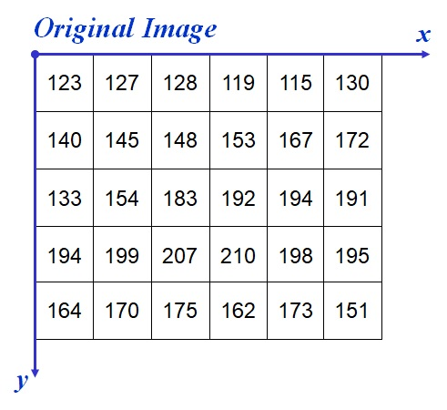  - Design the Algorithm for Laplacian Image Enhancement?  - Design the Algorithm for 1st Derivative Filtering?  - Design the Algorithm for Gradient Operation of Image Enhancement? | [4M]
3. | a) | Contrast various types of noise and their causes, which can corrupt an image? | [2M]
3. | b) | Given a 3x3 image matrix:  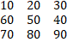  Add Rayleigh noise with a scale parameter b of 10. After computations, write the output matrix. | [4M]
3. | c) | Consider the following Image  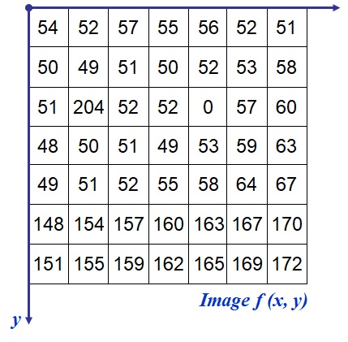  - Find the Output Image After applying Median Filter, Max Filter,  Midpoint filter  - Design an algorithm for Geometric Mean, Harmonic Mean and Contraharmonic Mean filter for noise removal for the same above Image. | [4M]
4. | a) | Explain basic steps for filtering of image in frequency domain. What are the filter mask used for low pass filtering and high pass filtering? | [2M]
4. | b) | Given a 2D image matrix  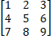  Compute Discrete Fourier Transforms (DFT) and Inverse Discrete Fourier Transforms (IDFT). | [4M]
4. | c) | Consider the hand X-ray images shown below. The image on the right was obtained by lowpass filtering the image on the left with a Gaussian lowpass filter, and then high pass filtering the result with a Gaussian high pass filter. The images are of size 420 x 344 pixels and D₀ = 25 was used for both filter transfer functions.  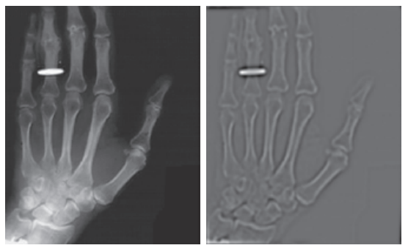  (i) Explain why the center part of the finger ring in the figure on the right appears so bright and solid, considering that the dominant characteristic of the filtered image consists of edges of the fingers and wrist bones, with darker areas in between. In other words, would you not expect the high pass filter to render the constant area inside the ring as dark, since a high pass filter eliminates the dc term and reduces low frequencies?  (ii) Design an algorithm for Butterworth filtering and Gaussian filtering for processing the images shown in the above question. | [4M]

SECTION - B
Answer all Two questions 2×20M=40M

5. | a) | Define Morphological Image Processing. Illustrate the Thinning and Thickening process by taking a sample image matrix. | [4M]
5. | b) | One black and white Image has been given along with the mask. Apply the mask as a structuring element and perform the flowing operations.  Erosion (ii) Dilation (iii) Opening (iv) Closing  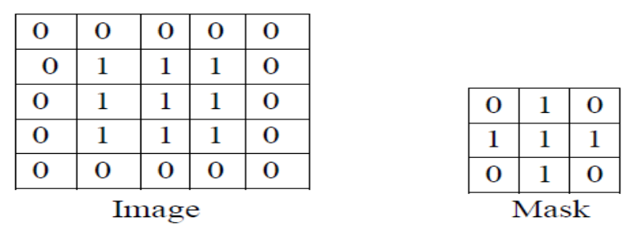 | [8M]
5. | c) | Design an algorithm for hole filling in binary image processing. How can morphological process applied to fill holes in binary objects, and what considerations are important in choosing the structuring element? | [8M]
6. | a) | Define Image compression? Differentiate the different types of image compression techniques and the image formats. | [4M]
6. | b) | Construct Huffman code for each gray level given and find the compression  ratio and coding efficiency.  Gray Level 0 1 2 4 5 6 7  No. of Pixels 30 35 38 15 10 38 80 | [8M]
6. | c) | Design an algorithm for LZW compression algorithm and Run-Length algorithm for compressing an image and analyze the results and specify the loss of information in image with metrics. | [8M]

